
LAB ASSIGNMENT NO :- 1

Circuit Diagram :-
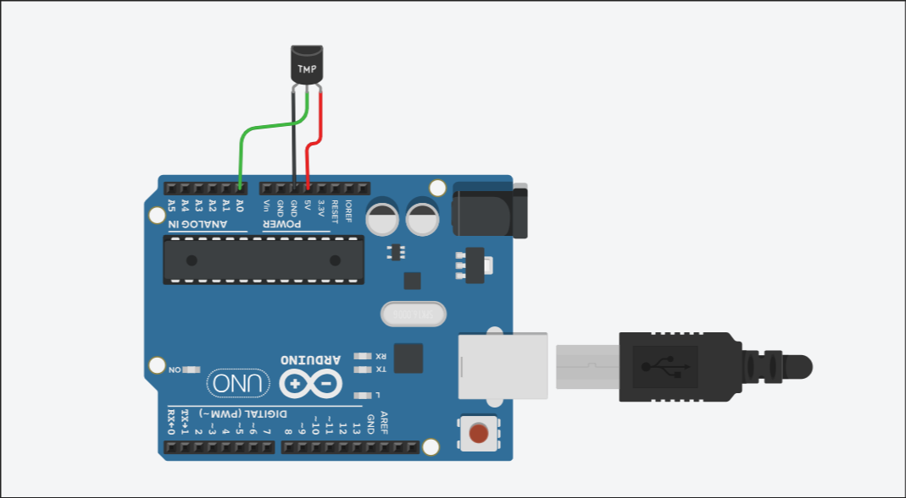

Code :-

#define TEMP_PIN A0
#define BUZZER_PIN 8

const float TEMPERATURE_THRESHOLD = 23.0;

void setup()
{
pinMode(BUZZER_PIN, OUTPUT);
Serial.begin(9600);
}

void loop()
{
int tempReading = analogRead(TEMP_PIN);

float voltage = tempReading * (5.0 / 1023.0);
float temperatureC = (voltage - 0.5) * 100.0;

Serial.print("Temperature: ");
Serial.print(temperatureC);
Serial.println(" C");

if (temperatureC > TEMPERATURE_THRESHOLD)
{
digitalWrite(BUZZER_PIN, HIGH);
Serial.println("ALERT: Temperature is too high!");

}
else
{
digitalWrite(BUZZER_PIN, LOW);
}

delay(500);
}

Output :-

Temperature: -40.22 C
Temperature: -26.05 C
Temperature: -9.92 C
Temperature: -0.15 C
Temperature: 15.98 C
Temperature: 42.86 C
ALERT: Temperature is too high!
Temperature: 42.86 C
ALERT: Temperature is too high

LAB ASSIGNMENT NO :- 2

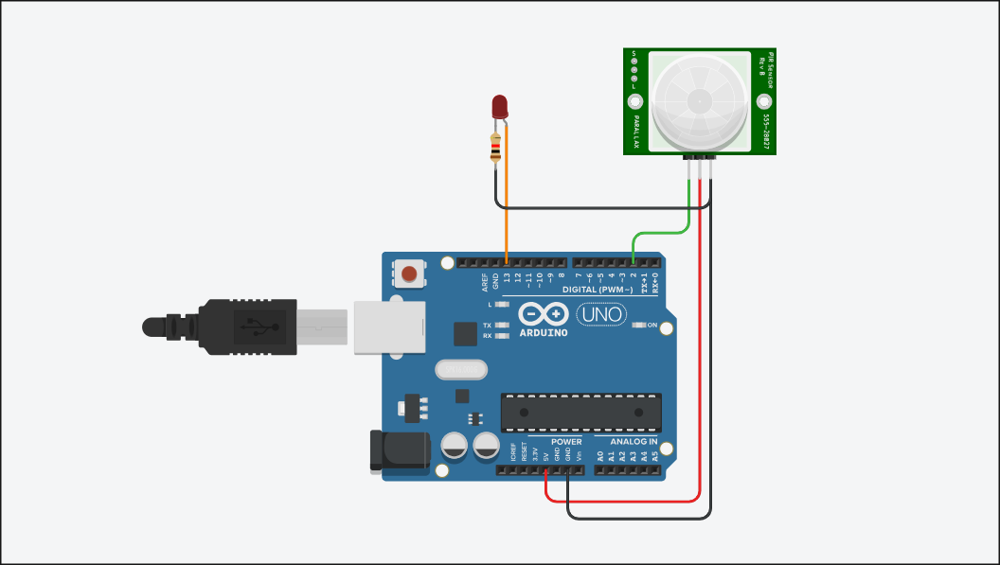
Circuit Diagram :-

Code:-

const int pirPin = 2;
const int ledPin = 13;

void setup()
{
pinMode(pirPin, INPUT);
pinMode(ledPin, OUTPUT);
Serial.begin(9600);
}

void loop()
{
int pirState = digitalRead(pirPin);

if (pirState == HIGH)
{
digitalWrite(ledPin, HIGH);
Serial.println("Motion detected!");
}
else
{
digitalWrite(ledPin, LOW);
Serial.println("No motion");
}

delay(1000);
}

Output:-

No motion
No motion
Motion detected!

